[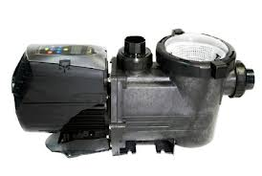](http://www.google.com.au/imgres?start=281&hl=en&biw=1920&bih=931&tbm=isch&tbnid=1146GatbMMB33M:&imgrefurl=http://poolshop.poolwerx.com.au/viron-evo-energy-efficient-pool-pumps.html&docid=m1xIw4Pr9CelUM&imgurl=http://poolshop.poolwerx.com.au/media/catalog/product/cache/1/image/9df78eab33525d08d6e5fb8d27136e95/p/6/p600_2.jpg&w=449&h=301&ei=qEMwUevgKouZkgWd4IDAAg&zoom=1&ved=1t:3588,r:82,s:200,i:250&iact=rc&dur=1379&sig=106600103780242943122&page=8&tbnh=184&tbnw=274&ndsp=40&tx=152&ty=130)[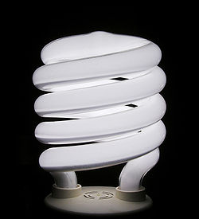](http://www.google.com.au/url?sa=i&rct=j&q=&esrc=s&frm=1&source=images&cd=&docid=zkC7pTYKlVHXvM&tbnid=VFRE9msqA9J5WM:&ved=0CAUQjRw&url=http://en.wikipedia.org/wiki/Efficient_energy_use&ei=FEMwUZ_ULYftkAXnk4G4Cg&bvm=bv.43148975,d.dGI&psig=AFQjCNEV3K2Tezqf9JCCoH8Ag5OJH8ppqA&ust=1362203769605679)Name:______________________

**Year 8 Physics**

**Energy Efficiency Assignment**

[](http://www.google.com.au/url?sa=i&rct=j&q=&esrc=s&frm=1&source=images&cd=&cad=rja&docid=rhmD8vKCfYCj6M&tbnid=GYw7k7Ofl_gHeM:&ved=0CAUQjRw&url=http://www.hanlonwindows.com.au/technical/energy-efficiency/&ei=ZEMwUcGiA8u-kQWIw4CwCA&bvm=bv.43148975,d.dGI&psig=AFQjCNEV3K2Tezqf9JCCoH8Ag5OJH8ppqA&ust=1362203769605679)

Choose one item, it could be anything eg house, i-pod or washing machine.

**Explain** 4 ways in which your item is energy efficient.

**Explain** one way in which your item could be made more energy efficient.

* [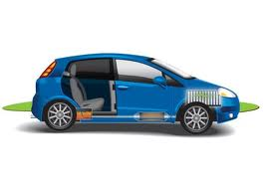](http://www.google.com.au/url?sa=i&rct=j&q=&esrc=s&frm=1&source=images&cd=&cad=rja&docid=lHXuQUNh7VDVBM&tbnid=qm47Hmt0YCCbJM:&ved=0CAUQjRw&url=http://www.dow.com/energy/rethink/transportation.htm&ei=t0MwUbimFcKJlAXyzYDQBQ&bvm=bv.43148975,d.dGI&psig=AFQjCNEHAeDIyi4H5Amr38GKsptl7MYGZA&ust=1362203928537401)Do not explain ways to reduce energy consumption such as turning off when not in use, explain ways your item is, or could be, efficient with the energy that comes in.
* You should include diagrams that have captions and that are referred to in your text.
* You will need to use more than one type of source to obtain your information (eg internet and book).
* Your report may be typed or hand written however you must attach your hand written notes.

**Marking Key**

Presentation 2

Clarity of explanations 2

4 existing points explained 12

*(for each point: one mark for listing, one mark for explaining, one mark for showing understanding)*

1 possible point explained 4

Diagrams used correctly (labelled, referred to in text) 3

Referenced as per student diary 3

/26